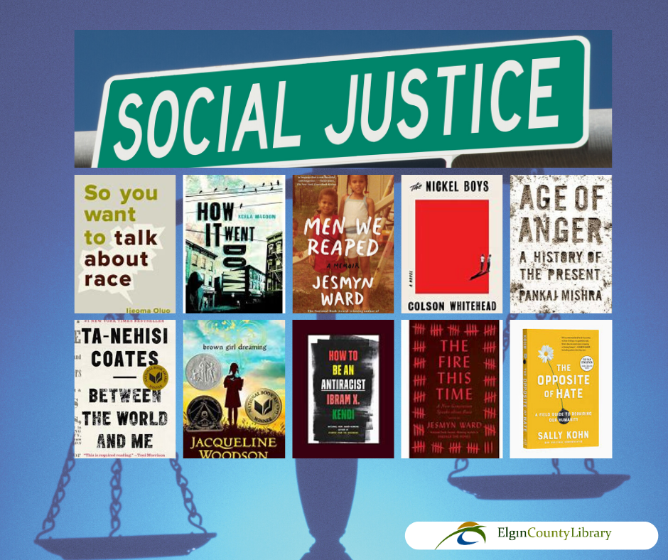

Here are just a few titles found at the Elgin County Library on the topic of Social Justice:
- Racism in Canada / Vic Satzewich - https://bit.ly/3n7Ly95
- From the ashes / Jesse Thistle - https://bit.ly/36llHnW
- Sway : unravelling unconscious bias / Pragya Agarwal - https://bit.ly/3kUJfEe
- How to be an antiracist / Ibram X Kendi - https://bit.ly/2SciwXp
- Me and white supremacy : combat racism, change the world, and become a good ancestor / Layla F. Saad - https://bit.ly/33dlbqe
- Seven fallen feathers : racism, death, and hard truths in a northern city / Tanya Talaga - https://bit.ly/3l3TJB8
- My Mother's Daughter : An Immigrant Family's Journey of Struggle, Grit and Triumph/ Felicien Perdita - https://bit.ly/3l53ort
- Old Bones/ Trudy Nan Boyce - https://bit.ly/36jA4ZX
- Age of anger: a history of the present / Pankaj Mishra - https://bit.ly/3cIzENY
- The fire this time: a new generation speaks about race / edited by Jesmyn Ward - https://bit.ly/3ihWgpF
- White rage: the unspoken truth of our racial divide / Carol Anderson - https://bit.ly/3ldrHnd
- Go tell it on the mountain / James Baldwin - https://bit.ly/2Gsu06o
- Between the world and me / Ta-Nehisi Coates - https://bit.ly/33lXXyp
- Home / Toni Morrison - https://bit.ly/2SaR647
- Antiracist Baby / Ibram X. Kendi ; illustrated by Ashley Lukashevsky - https://bit.ly/36k4b3r
- Go to school, you're a little black boy: the Honourable Lincoln M. Alexander : a memoir / [with Herb Shoveller] - https://bit.ly/3ihCxqf
- Skin in the game: Hidden Asymmetries in Daily Life / Nassim Nicholas Taleb - https://bit.ly/3kYG1Qc
- Dreams from my father: a story of race and inheritance / Barack Obama - https://bit.ly/2GoTIJ0
- Don't let's go to the dogs tonight: an African childhood / Alexandra Fuller - https://bit.ly/30jDXKC
- My life, my love, my legacy by Coretta Scott King ; as told to the Rev. Dr. Barbara Reynolds - https://bit.ly/3n7JFJx

New to Elgin County Library? Please follow this step by step guide to order materials online and access digital content. No library card? No problem! Go to the link below to apply for a digital library card to gain access to books, databases, entertainment, audiobooks, magazines and more: https://www.elgincounty.ca/library/online-membership/
